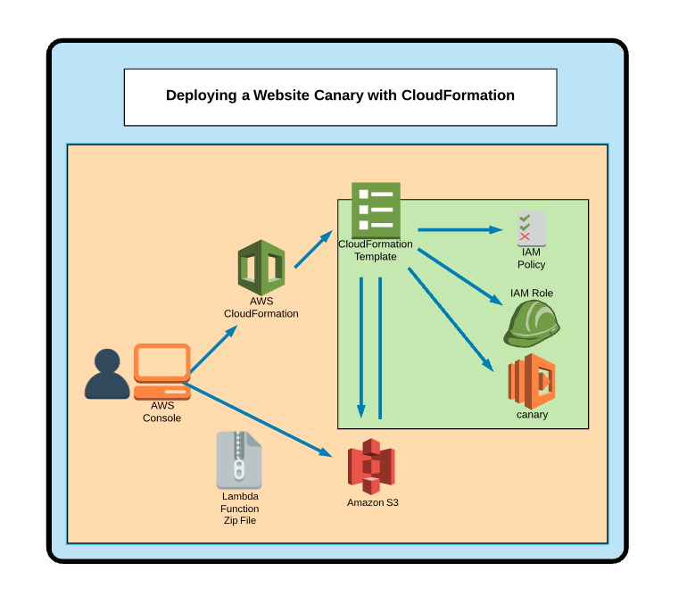
Additional Information and Resources
Make sure you are in us-east-1 when doing this activity.
The code samples for this are here: https://github.com/linuxacademy/aws-cda-2018/tree/master/cloudformation/lab-files

Deploying a Website Canary with CloudFormation

Introduction
In this lab, we'll use AWS CloudFormation to deploy our own website Canary application.
Log in to the AWS console with the cloud_user credentials provided on the lab page, and make sure you are in us-east-1 throughout the lab.
Once you're logged in, navigate to S3. Then, open CloudFormation in a new browser tab. We'll leave both tabs open as we work with them throughout the lab.

Upload a Lambda Function Zip File Deployment Artifact to S3
First, we're going to upload a deployment zip package to S3 inside the AWS console so our CloudFormation template can rely on it during the creation process.
- Navigate to S3.
- Click + Create bucket.
- On the Name and region screen, give your bucket a globally unique name — in addition to "website-canary-2018-cf-test", you could append your name, favorite animal, and some random letters. Copy the bucket name into a note or text file on your desktop — we'll need it again later. Click Next.
- Click Next two more times, leaving the default settings on the subsequent screens, and finally click Create bucket.
- Click into the bucket, and click Upload.
- Upload the canary.zip file from the GitHub repository here into the S3 bucket.

Create a CloudFormation Stack
Now, we'll create a CloudFormation stack in the AWS console using the designer and the code samples provided.
- Head to the CloudFormation browser tab.
- Click Create Stack, and then click Design template.
- Select the Template tab of the editor.
- Paste in the code from the sample cftemplate.json file here.
- In the Code section of the template, enter the name of your bucket where it says "S3Bucket": "REPLACEME".
- In the Properties portion of the LambdaCanaryFunction section of the template:
  - Update the site with the name of the website you'd like to check (including https://)
  - Update expected with some text you might expect to see on that site.
  - Update phone with the phone number at which you want to receive a text notification (including + and your country code — e.g., 1 for the United States).
- Click the checkbox icon in the top left to validate the template.
- Click the upload icon in the top left to create the stack.
- This brings us back to the Create stack page we saw in the beginning, but now our Amazon S3 template URL is auto-filled. Click Next.
- Give the stack a name (e.g., "cf-test-2018-canary"), and click Next.
- We don't need to do any configuration on the Options page, so click Next.
- On the Review page, check the box to acknowledge AWS CloudFormation might create IAM resources, and click Create.
- If you don't see the stack listed yet, click the refresh icon. It should then show the creation is in progress.

Test the Lambda Function
- Navigate to Lambda via the Services menu at the top.
- Click into the listed Lambda function.
- Click the Select a test event dropdown at the top, and select Configure test events.
- In the Event template dropdown, search for "Amazon CloudWatch".
- Give it an Event name of "test".
- Click Create.
- Click Test at the top. You should receive a text message letting you know the check passed.

Conclusion
Congratulations on completing this lab!

